
ACET KS3-5 Assessment, Feedback and Reporting Policy

DATE: November 2024
POLICY LEAD: Helen Care
APPROVED BY: C&S Committee

DOCUMENT CONTROL
Policy Level | Trust (Senior)
Approved By | Trustees (C&S Committee)
Approval Date | 27.01.2025
Next Review Date | November 2025 | FREQUENCY | Annual
Business Lead | R Hibberd | Author | Helen Care
VERSION NUMBER | DATE ISSUED | UPDATED INFORMATION
V2 | November 2024 | Revised versions of KS3 ARE descriptors. Amendment to Y13 trial exam venues. Amendment to number of Y11 trial exams.  Amendments to wording of feedback / response and data collection sections.

Principles

The purpose of assessment, feedback and response is to help teachers, students and parents/carers to understand how learning is progressing and to enable students to improve and develop their metacognitive skills.

Assessments should indicate the extent to which students know and remember the intended subject curriculum. Teachers should use assessment information to identify gaps in students’ knowledge of components and therefore inform their curriculum planning and delivery.

Feedback on assessments should ensure students know what they have done well and what they need to do to improve.

Assessment methods should not increase teacher workload unduly.

The assessment process is an essential aspect of the role of a teacher, as reflected
in the Teacher Standards:

Teacher Standard 6 - Make accurate and productive use of assessment

- Know and understand how to assess the relevant subject and curriculum areas, including statutory assessment requirements

- Make use of formative and summative assessment to secure students’ progress

- Use relevant data to monitor progress, set targets, and plan subsequent lessons

- Give students regular feedback, both orally and through accurate marking, and encourage pupils to respond to the feedback

Formative Assessment in lessons

Formative assessment takes place on a day-to-day basis during lessons, allowing teachers and students to assess attainment and progress. It means providing teaching that is adaptive to students’ needs and using evidence about learning to adjust instruction to ensure that learning moves forward.

Teachers use student responses to shape the direction of learning during a lesson and to plan future lessons, ensuring the level of challenge is correct, misconceptions are being addressed and that students have opportunities to apply their understanding.

Formative assessments: Progress Check assessments

These assessments are low stakes, often open-book assessments that take place in line with subject curricula as a frequency determined by the head of faculty, but broadly every 6-8 lessons. These are designed to identify whether students understand and can apply the knowledge and skills developed across a scheme of work. They include assessment of both the component and composite knowledge of a subject. Components are the building blocks that together, when known, allow successful performance of a complex task. A composite task requires several building blocks or components.

These formative assessments are graded using age-related expectations at KS3 and against GCSE/vocational criteria at KS4 and KS5. The classroom teacher marks a student’s response and provides appropriate feedback to support improvement (see below). At KS3, the age-related expectation grades used to assess a progress check are for teacher information only and are not shared with students as part of the written feedback.

All progress check assessments must be printed on yellow paper and stuck in students’ exercise books (or folders) on completion.

Standardised Summative Assessments (trust-wide)

Standardised summative assessments are unseen assessments that test learning over time. These are placed at appropriate points throughout the year, with respect to individual subject curriculum plans. Teachers mark these against age-related expectations at KS3 and against GCSE/vocational criteria at KS4 and KS5, providing appropriate feedback to support improvement (see below).

At KS3, students sit two trust-wide standardised summative assessments (SSA) per year. In English, maths and science, students sit one SSA in an examination hall to build experience and resilience for external examinations in KS4 and KS5. All other SSAs are classroom-based.

 | Year 7 | Year 8 | Year 9
SSA1 | HT2 window (classroom-based, individual academies to set specific dates) | HT2 window (classroom-based, individual academies to set specific dates) | HT2 window (classroom-based, individual academies to set specific dates)
SSA2 | First two weeks in May  En/Ma/Sc: exam hall  All other subjects: classroom-based | HT6 window (individual academies to set specific dates)  En/Ma/Sc: exam hall  All other subjects: classroom-based | HT4 window (individual academies to set specific dates)  En/Ma/Sc/ MFL/Geog/Hist/RE: exam hall  All other subjects: classroom-based

The standardised summative assessments are 50 minutes in length and are written in conjunction with and quality assured by the ACET strategic team. Aspects of each SSA may also be adapted to meet the needs of an individual academy’s curriculum with any such changes being approved by a member of the ACET strategic team. SSAs are graded using the ACET age-related expectations at KS3. Some subjects may mark using a percentage which is then converted to an age-related expectation grade using a conversion table produced by the strategic team.

Key Stage 4 students sit two sets of standardised summative assessments per year in all subjects. Key Stage 5 students sit three sets. Again, these are written in conjunction with and quality assured by the ACET strategic team, as per KS3 SSAs. They are graded using the relevant examination board assessment criteria.

 | Year 10 | Year 11 | Year 12 | Year 13
SSA1 | December  (classroom-based) | November  Trial exams in En/Ma/Sc/ MFL/Humanities  (exam hall-based)  SSA1 in all other subjects  (classroom-based) | Late October-Early November  (classroom-based) | November  (exam-hall based)
SSA2 | Late June-Early July  End of Y10 exams (exam hall-based) | March  Trial exams in all subjects  (exam hall-based) | February  (classroom-based) | January  Trial exams  (exam hall-based)
SSA3 | N/A | N/A | Late June-Early July  End of Y12 exams (exam hall-based) | March  (classroom-based)

All standardised summative assessments must be printed on blue paper and stuck in students’ exercise books (or folders) on completion.

Feedback and Response
Students are given regular feedback in lessons to help them reflect and progress. However, they are given more structured feedback following progress check and standardised summative assessments, when they are also given the opportunity to reflect and respond independently. This may take the form of handwritten comments or a pre-populated feedback sheet specific to a particular assessment. Examples of effective feedback are included in Appendix 2.
At all key stages, progress check and standardised summative assessments must be graded (KS3 ARE, GCSE, A level or vocational grading) and teachers must provide written feedback in the form of comments which indicate strengths and areas for developments, to which students respond. Grades are not shared with students on progress check assessments. Broadly, teachers should return marked progress check and standardised summative assessments to students within two lessons of the assessment date.
KS3 age-related expectations are as follows. Each subject has clear descriptors for each of the four age-related expectations at Year 7, Year 8 and Year 9.
GD+ | Greater Depth Plus
GD | Greater Depth
AR | Age Related
AS | Approaching Standard
Effective practice is achieved through:
- High quality feedback – students understand their achievements and next steps
- High quality student response – students can apply their next steps independently to secure progress
Teachers mark written assessments in red or green pen, and students respond in purple pen. Spelling, punctuation and grammar errors are corrected, as appropriate. The term ‘Feedback and Response’ should be used when students complete their response to teacher feedback.
Tracking and Monitoring of Assessments
Formative and summative assessments are marked by teachers and recorded at faculty level to enable the identification of whole cohort, class and individual student areas of strength and development. This then informs future planning of the curriculum, individual lessons, and teaching and learning in the classroom.

Target-setting

At KS3, KS2 scaled scores are used to set minimum targets using ACET age-related expectations. All students with a KS2 scaled score of 85 and above will have a minimum target of AR (age-related) as the aim is for all students to be supported in reaching a minimum standard of AR. Targets are reviewed on an annual basis based on analysis of KS3 data collections.

KS3 targets are set as follows:

KS2 Scaled Score | KS3 Target | GCSE Expected Grades
110+ | GD+ | 8-9
105-109 | GD | 6-8
100-104 | AR | 5-6
85-99 | AR | 3-5
84 | AS | 1-3

At KS4, Fischer Family Trust data is used to set FFT20 targets (high progress) based on KS2 scaled scores. FFT5 is used at Aston Academy only to set targets for HPA students.

At KS5, Department for Education level 3 value added published data is used to set minimum target grades which set students on a trajectory to a positive value-added score. The value-added score measures the progress students make between KS4 and the end of their level 3 qualification in KS5. Where FFT5 targets are available, these are used in the first instance for all A level subject targets as these are comparable with the L3VA calculations. The minimum A level target grade for all students is set a grade C, regardless of the FFT5 or L3VA target. Students with grade 9 at GCSE in the subject being studied at A level will be considered for an A* target by the Post 16 team, regardless of the FFT5 or LV3A target.

Data Collections and Reporting to Parents/Carers

Years 7-10 have two data collection points during the year, Years 11-13 have three data collection points per year. These are aligned across the trust to facilitate the setting, marking and moderation of standardised summative assessments and the subsequent analysis of data. The data collection points are informed by both formative and summative assessment as well as professional judgement, resulting in a holistic progress grade. Year 11 DC2 is informed by progress checks, other classroom-based data and any catch-up from November trials where students were absent. A report is sent home to parents/carers after each collection. At KS3, data is reported in the form of an academic achievement grade, which reflects age-related expectations specific to each subject. At KS4 and KS5, current and estimated end of course grades are reported, which reflect GCSE/ A level/ vocational criteria. At GCSE, APS (average point score) is also reported. At all key stages, reports include the student’s end of key stage minimum target grade. A character in the classroom grade is also reported at all three key stages. KS3 reports include New Group Reading Test (NGRT) data.
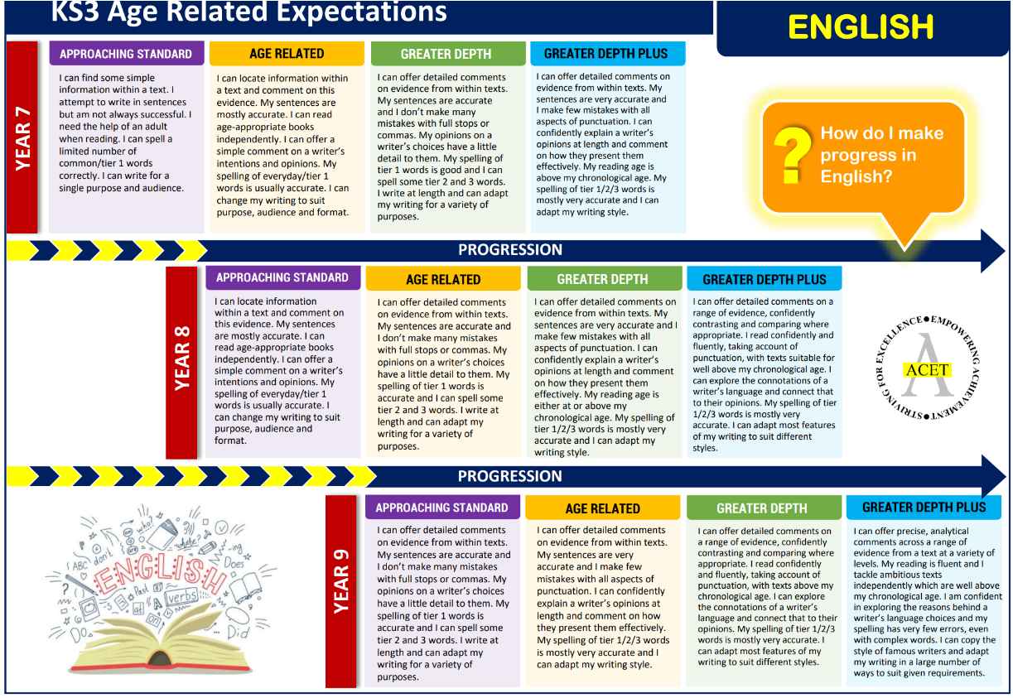
Appendix 1 – Examples of KS3 Age Related Expectations Descriptors
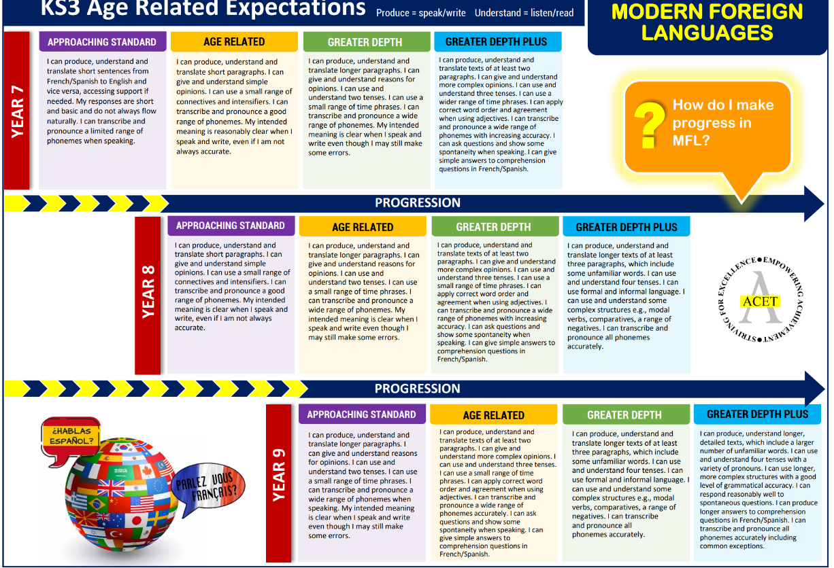

Appendix 2 – Examples of effective feedback
You have included key details from the source and linked it to your own knowledge.
Now comment on the provenance of the source. Who wrote it? When? Why? Is it a reliable piece of evidence?

You gave opinions and justified them; your pronunciation has improved.
Include intensifiers. Find three in Spanish and write a short sentence including one of them.

You made reference to the extract and text as a whole and included relevant quotations.
Develop your analysis of the writer's methods. What does the language tell us? How does it link to ambition? What are the connotations?

Your definition for muscular endurance is detailed and includes key words
Now include two examples in sporting situations where good muscular endurance is essential.

You have reached a conclusion.
In your conclusion, explain why ... was the most important reason. Substantiate your answer with reasons/examples.

