KS4 Pathways 2024
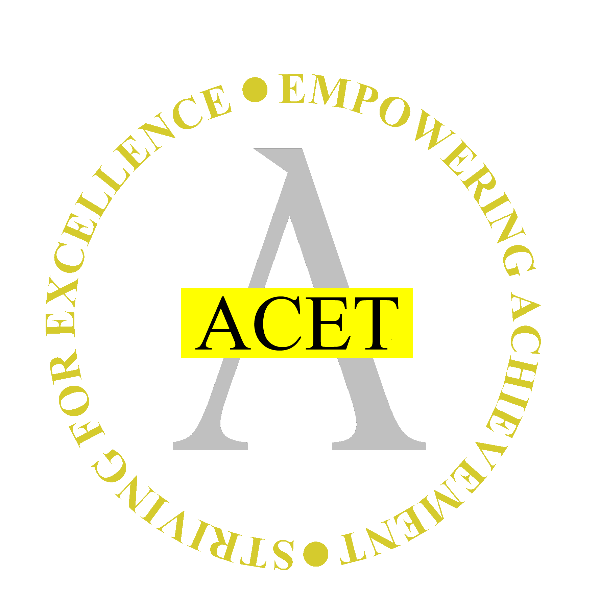
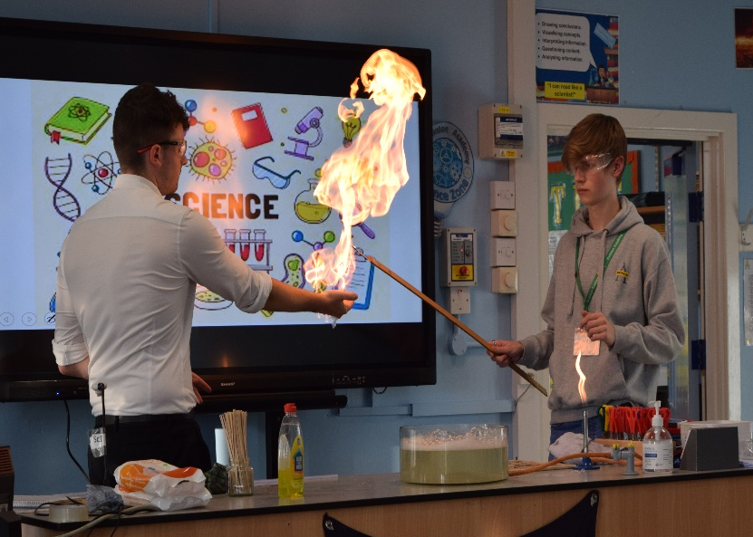
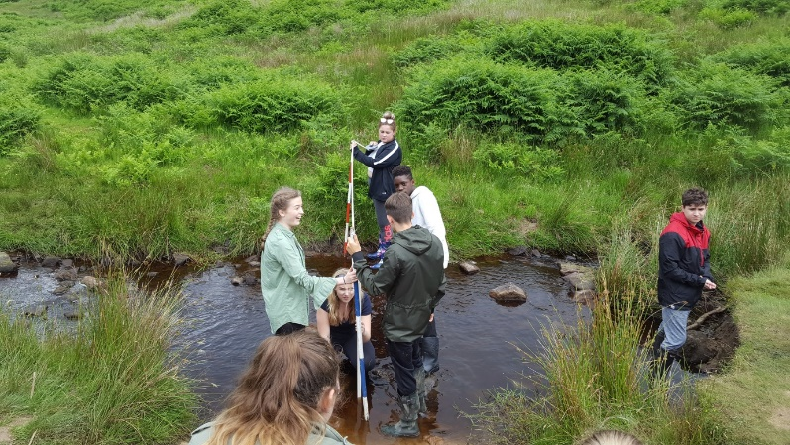




“ At Swinton Academy,
we will make a difference ”

Letter from our Principal
Swinton Academy


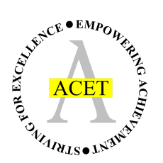


Principal - James Graham BSc (Hons) PGCE

Chair of Governors – David Lennox

Executive Principal - Rebecca Hibberd BEd (Hons), MA

ACET CEO - Rebecca Scutt BSc (Hons) PGCE

Sandra Moore BA MEd - Vice Principal

East Avenue
Swinton
Mexborough
S64 8JW
Tel: 01709 570 586
Email: enquiries@swintonacademy.org
Web: www.swintonacademy.org

KS4 Pathways

January 2024
Dear Y9 Student, Parents and Carers
KS4 Pathways 2024
At Swinton Academy, our ambition is to offer you a broad and balanced curriculum; one that will allow you to develop your subject knowledge and skills in many different disciplines, as well as developing your personality, preparing you fully for life beyond school. Our hope, then, is that by the time you reach the end of KS4 you have the necessary skills, experiences and qualifications to make informed decisions about the next stage of your academic career.
Due to many subjects being compulsory your option choices are limited, so when making your choice I urge you to select a subject that you enjoy and will excel in. All Y9 students will have the opportunity to discuss their choices with members of staff in school, member of the academy’s leadership team or a member of your year team. Here we will be able to advise you if your career aspirations require you to study a particular GCSE course. We are also happy to meet with your parents/carers at this important time.
Along with your parents/carers, we encourage you to read all the information within this booklet. It will help you to understand the recent changes that have taken place linked to study at KS4. It also offers information about the new GCSE grading system.
I know that you have been looking at career options in tutorial time but should you need any further information then please contact your year team who will only be too happy to organise a careers interview for you. To book a careers appointment, please email ssykes@swintonacademy.org or speak to the year team and we can help to organise this for you.
To help students make the best possible decisions which will increase opportunities in the future, and for you to guide your child, we will offer a range of support throughout the term.
These include:
This options booklet for each student which gives useful information about each subject, what students will learn, how it is assessed and which future careers/pathways it will support.
A Y9 options google classroom (code 7bdxrkj)– each Y9 student will be signed up to the Y9 option choices classroom. Information within this classroom will be added too throughout the term to include guidance on how to choose options, careers information, labour market research and details on the option process.

1

1
KS4 Pathways
Information slides by each head of faculty detailing key GCSE information for their subjects. This will give you and your child a more in depth understanding of each subject, what the course entails, how it is assessed and how the subject can link to post 16 study and careers. They are available from the google classroom.
Y9 monitoring – this will be e-mailed home to you on week beginning 22nd January. It will detail your child’s progress in each subject, their attitude to learning and subject target grade. This will inform you of the subjects/areas your child is stronger in and the areas for development.
Y9 Consultation Evening – this is a live event and will be held at the academy on Monday 5th February. The evening will give you and your child an opportunity to speak directly to class teachers focusing on progress and option choices.
Y9 assemblies – Our weekly Y9 assembly (held each Friday) will focus on providing students with advice around choosing options – this might include career information, Post 16 information, subject combinations and advice on how to choose the best subjects for you. All Heads of Faculty for options choice subjects will address the Year 9 Cohort throughout this half term, outlining what each subject is about, how it is assessed and how it links to future study and careers.
We wish all our Y9 students the best of luck as they make the important transition into KS4 (Y10 -11).
Yours faithfully
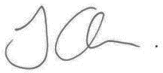
Mr James Graham
Principal

Introduction
It is an exciting time for Y9 students. We ask that parents/carers and students go through the information contained in this booklet together so you and your child will be able to discuss the courses that will be studied.
Their deadline for returning their pathway forms is: Friday, 1st March 2024. These will be handed out in assembly on Friday 9th February and distributed via email. They need to be returned via e-mail to kyuill@swintonacademy.org, or alternatively return the completed form to the attendance office.

New Style GCSE
The Government have introduced a programme of GCSE reform, and all KS4 courses offered at Swinton Academy follow this new format. Key features of the new GCSEs are:
• All GCSE exams will be studied in a linear format and be taken in the Summer of Y11
• There will be greater emphasis on spelling, punctuation and grammar
• All courses will be more rigorous, demanding and challenging
• There will be tiered exam papers in Mathematics, Science and Modern Foreign Languages
• The grade scale for these new GCSEs now range from 9 to 1, with 9 being the highest.
There are two main types of qualification, ‘GCSE’ and ‘Technical’.
The General Certificate of Secondary Education (GCSE) is a primarily exam-based qualification, which may include some coursework or practical work, depending on the nature of the subject.
Technical qualifications result in a Level 2 qualification, which is equivalent to a ‘GCSE’. The final qualification is mainly based on coursework that takes place throughout the course but all Technical courses also feature an examined element.
New GCSE Grading:
New GCSE Grade | Equivalent Traditional Grade
9 | A* (Top 3% nationally)
8 | A*
7 | A
6 | Top grade B
5 | B/C
4 | C
3 | D
2 | E
1 | F/G
New Technical Grading:
Old Grade | New Grade
Level 2 Distinction | 8
Level 2 Merit | 6
Level 2 Pass | 4
Level 1 Distinction | 3
Level 1 Merit | 2
Level 1 Pass | 1
Unclassified | 0

3
KS4 Pathways
KS4 Curriculum

KS4 Curriculum
Our KS4 curriculum offers a wide range of subjects which provides you with a variety of academic and vocational courses to choose from. It is important to read about the subjects mentioned in this booklet carefully as it will help you understand what is expected of you next year. After September of the year you start your GCSEs you will not be able to change courses so please select carefully.
Core Subjects
There are some subjects that you have to study; these are compulsory subjects:
- English Language and Literature
- Mathematics
- Science (Combined)
- PE/Sport – 1 hour practical, non-examined.
- Religious Studies
- Geography or History
- For some students, a Modern Foreign Language will also be compulsory.
English Baccalaureate (EBacc)
The EBacc is not a qualification in itself. It is a particular group of GCSE subjects looked on favourably by Universities. The Baccalaureate subjects are English, Maths, the Sciences (including Computer Science), History or Geography and a Modern Foreign Language. You do not need to have studied all of these subjects to go to University but having your GCSE mix steered towards English Baccalaureate subjects will help to keep your options open.
How to choose
PLEASE CHOOSE SUBJECTS YOU:
- Like and ones which excite, motivate and interest you
- Feel might help you in the general career area that you are interested in, such as ‘working with people’ or ‘using practical skills’.
- Find out exactly what each course involves by reading this booklet
- Ask your teachers for advice and support about courses that would be best for you.
If I want to go on to study at Swinton Academy Post 16 in the future, which subjects would be best?
There are no ‘best’ options to prepare you for further study. Keep your options broad and balanced. If you wish to study Post 16 at Swinton good passes in your KS4 courses are required. Our Post 16 prospectus will help guide you further. To view the prospectus please visit our website www.swintonacademy.org and click on the Post 16 tab. For any queries or further information, please email post16@swintonacademy.org
Can I change my mind later?
The subjects you choose are for the next two years. Therefore, it is very important that the right choice is made at the outset. It is only in exceptional circumstances that students are permitted to change their courses but not after September of Y10.

KS4 Pathways
4

YEAR 10 C O R E
English Language

Examination
100% written examination – Eduqas exam board.
Component 1 (1 hour and 45 minutes): Fiction Reading and Writing
Component 2 (2 hours): Non-fiction Reading and Writing

Career and Post 16 studies
A Levels in English Language and English Literature are obviously supported by this GCSE, as are A Levels or further study in MFL, Film and Media, Business, and Performing Arts.
English qualifications are always useful in any career and help with communication skills, but sectors such as Law, Business, Education, Media, and Public Relations are all areas you could explore more easily with a good GCSE Language grade.
If you do not pass this GCSE course by the end of Year 11, you will be required to study the qualification and re-sit the examination. Pass = grade 4 or above, and the re-sit is with a Post 16 provider, such as Swinton Academy.

“At Swinton Academy, we will make a difference”

Useful skills to support learning
- Extended writing
- SPaG
- Reading a variety of texts
- Note-making
- Debating/Discussion
- Empathetic response
- Research skills
- Confidence and creativity
- Creative writing

In this subject you will study
- Fiction Reading: a range of genres, short stories and novels
- Fiction Writing: narrative and descriptive writing to unlock your imagination
- Non-fiction Reading: unfolding the real world. Studying a range of media, expanding your understanding of real-life concepts
- Non-fiction Writing: persuasive and argumentative opinion writing about real-life scenarios
- Spoken Language: a presentation/speech on a topic of your choice (this must be completed to be awarded your GCSE qualification)

Subject Introduction
English Language is one of the two English GCSE qualifications that you will take and is a compulsory course.

In English Language you will read and write a variety of texts, considering the impact of language choices made by each writer, including yourself and your peers. You will explore a range of both fiction and non-fiction texts and be sure to find the style of writing that you enjoy most. There are opportunities for reading aloud, investigating a range of ideas in groups or as a class – you’ll even with the opportunity to argue your points through a topical debate! You will develop your analytical skills and creative writing giving you plenty of chances to interpret the world around you through the written and spoken word.


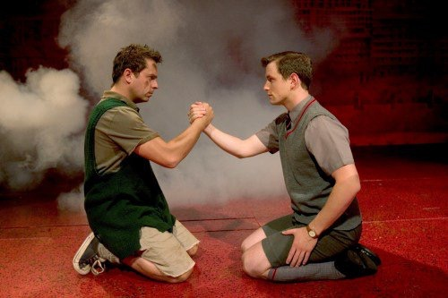
YEAR 10 C O R E
Examination
100% written examination – Eduqas exam board.
Component 1 (2 hours): ‘Macbeth’ and Poetry
Component 2 (2 hours and 30 minutes): ‘Blood Brothers’ and ‘A Christmas Carol’ and Unseen Poetry.

Career and Post 16 studies
A Levels in English Language and English Literature are obviously supported by this GCSE, as are A Levels or further study in MFL, Film and Media, Business, and Performing Arts.
English qualifications are always useful in any career and help with communication skills, but sectors such as Law, Business, Education, Media, and Public Relations are all areas you could explore more easily with a good GCSE Literature grade.

Subject Introduction
English Literature is one of the two English GCSE qualifications that you will take and is a compulsory course.
In English Literature, you will study a variety of different texts and forms of media related to them, explore the backgrounds of writers and poets, and think about how these texts and performances affect you and other readers. There are opportunities for drama-based activities, performing, reading aloud, and debating ideas in groups or as a class, alongside essay writing where you can present your ideas in a formal and creative manner.

English Literature
“At Swinton Academy, we will make a difference”

Useful skills to support learning
- Extended writing
- SPaG
- Note-making
- Debating/Discussion
- Empathetic response
- Research skills
- Confidence and creativity

In this subject you will study
- Shakespearean drama: ‘Macbeth’ by William Shakespeare.
- 19th century prose: ‘A Christmas Carol’ by Charles Dickens.
- Modern drama: ‘Blood Brothers’ by Willy Russell
- Poetry Anthology
- Unseen Poetry.

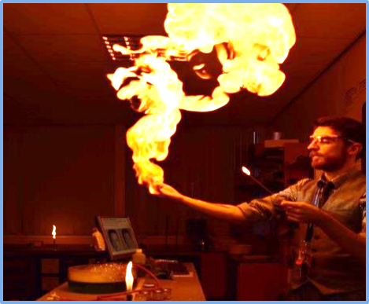
YEAR 10 C O R E
Subject Introduction
GCSE study in Combined Science provides the foundations for understanding the physical , living and material world.
Scientific understanding is changing our lives and is vital to the world’s future prosperity, and all students should be taught essential aspects of the knowledge, methods, processes and uses of science.
Studying Combined science will result in two GCSE grades.

In this subject you will study
Cell Biology; Organisation; Infection and response; and Bioenergetics. Homeostasis and response; Inheritance, variation and evolution; and Ecology
Atomic structure and the periodic table; Bonding, structure, and the properties of matter; Quantitative chemistry; Chemical changes; and Energy changes. The rate and extent of chemical change; Organic chemistry; Chemical analysis; Chemistry of the atmosphere; and Using resources.
Energy; Electricity; Particle model of matter; and Atomic structure. Forces; Waves; and Magnetism and electromagnetism.

Examination
There are six papers for GCSE Combined science at the end of Y11.
Each of the six papers will assess knowledge and understanding from distinct topic areas in either Biology, Chemistry, and Physics (weighting 16.7% per paper).
Each exam is a written paper lasting 1hr 15 minutes.
Questions are a mixture of multiple choice, structured, closed short answer, and open response.

Useful skills to support learning
Students will develop knowledge and understanding in science through opportunities for working scientifically completing a minimum of 21 required practicals throughout the GCSE course.

Students will not only develop practical skills but also work as a group, apply mathematical skills, develop their extended writing and explore ethical issues.

Career and Post 16 studies
Further study at A level, this includes Biology, Chemistry, Physics and Applied science. Astronomer, Technician, Aviation, Chemist, Teacher, Electrician, Film and Video Editor, Food Scientist, Forensic Scientist, Nuclear Technician, Nuclear Power Operator, Occupational Health Specialist, Physicist, Physiotherapist, Pilot, Sound Engineer, Doctor, Nurse, Pharmacist, Dentist, Marine Biologist, Veterinarian, Veterinary Nurse, Optician, Chemical Engineer, an endless list!

Combined Science
“At Swinton Academy, we will make a difference”

“At Swinton Academy, we will make a difference”
*All 3 separate sciences must be taken together. Only available for “A Band” students

YEAR 10 Options
Career and Post 16 studies
Further study at A level, this includes Biology, Chemistry, Physics and Applied science. Microbiologist, Chemist, Teacher, Electrician, Film and Video Editor, Food Tester, Food Scientist, Forensic Scientist, Nuclear Technician, Nuclear Power Operator, Occupational Health Specialist, Physicist, Physiotherapist, Pilot, Ship Captain, Sound Engineer, Doctor, Nurse, Pharmacist, Dentist, Marine Biologist, Veterinarian, Veterinary Nurse, Optician, Chemical Engineer, an endless list!

Examination
There are two papers for GCSE Biology.
Each of the papers will assess knowledge and understanding from distinct topic areas (weighting 50% per paper)
Each exam is a written paper lasting 1hr 45 minutes.
Questions are a mixture of multiple choice, structured, closed short answer, and open response.

Subject Introduction
GCSE study in Biology provides the foundations for understanding the living world. Scientific understanding is changing our lives and is vital to the world’s future prosperity, and all students should be taught essential aspects of the knowledge, methods, processes and uses of science.

Following the separate sciences route provides a firm foundation for A levels and further study in Science.

Useful skills to support learning
Students will develop knowledge and understanding in Biology through opportunities for working scientifically completing a minimum of 10 required practicals throughout the GCSE Biology course.

Students will not only develop practical skills but also work as a group, apply mathematical skills, develop their extended writing and explore ethical issues.

In this subject you will study
Paper 1: Cell biology; Organisation; Infection and response; and Bioenergetics.

Paper 2: Homeostasis and response; Inheritance, variation and evolution; and Ecology.

Separate Science:
Biology*

“At Swinton Academy, we will make a difference”
*All 3 separate sciences must be taken together. Only available for “A Band” students

YEAR 10 Options
Career and Post 16 studies
Further study at A level, this includes Biology, Chemistry, Physics and Applied science. Astronomer, Technician, Aviation, Chemist, Teacher, Electrician, Film and Video Editor, Food Tester, Food Scientist, Forensic Scientist, Nuclear Technician, Nuclear Power Operator, Occupational Health Specialist, Physicist, Physiotherapist, Pilot, Ship Captain, Sound Engineer, Doctor, Nurse, Pharmacist, Dentist, Veterinarian, Veterinary Nurse, Optician, Chemical Engineer, Marine Biologist, an endless list!

In this subject you will study
Paper 1: Atomic structure and the periodic table; Bonding, structure, and the properties of matter; Quantitative chemistry, Chemical changes and Energy changes.

Paper 2: The rate and extent of chemical change; Organic chemistry; Chemical analysis, Chemistry of the atmosphere; and Using resources.

Useful skills to support learning
Students will develop knowledge and understanding in Chemistry through opportunities for working scientifically completing a minimum of 10 required practicals throughout the GCSE Chemistry course.

Students will not only develop practical skills but also work as a group, apply mathematical skills, develop their extended writing and explore ethical issues.

Separate Science:
Chemistry*
Examination
There are two papers for GCSE Chemistry.
Each of the papers will assess knowledge and understanding from distinct topic areas (weighting 50% per paper)
Each exam is a written paper lasting 1hr 45 minutes.
Questions are a mixture of multiple choice, structured, closed short answer, and open response.

Subject Introduction
GCSE study in Chemistry provides the foundations for understanding the material world. Scientific understanding is changing our lives and is vital to the world’s future prosperity, and all students should be taught essential aspects of the knowledge, methods, processes and uses of science.

Following the separate sciences route provides a firm foundation for A levels and further study in Science.

“At Swinton Academy, we will make a difference”
*All 3 separate sciences must be taken together. Only available for “A Band” students

YEAR 10 Options
Useful skills to support learning
Students will develop knowledge and understanding in Physics through opportunities for working scientifically completing a minimum of 10 required practicals throughout the GCSE Physics course.

Students will not only develop practical skills but also work as a group, apply mathematical skills, develop their extended writing and explore ethical issues.

Career and Post 16 studies
Further study at A level, this includes Biology, Chemistry, Physics and Applied science. Astronomer, Technician, Aviation, Chemist, Teacher, Electrician, Film and Video Editor, Food Tester, Food Scientist, Forensic Scientist, Nuclear Technician, Nuclear Power Operator, Occupational Health Specialist, Physicist, Physiotherapist, Pilot, Ship Captain, Sound Engineer, Doctor, Nurse, Pharmacist, Dentist, Veterinarian, Veterinary Nurse, Optician, Chemical Engineer, Marine Biologist, an endless list!

Subject Introduction
GCSE study in Physics provides the foundations for understanding the physical and material world. Scientific understanding is changing our lives and is vital to the world’s future prosperity, and all students should be taught essential aspects of the knowledge, methods, processes and uses of science.

Following the separate sciences route provides a firm foundation for A levels and further study in Science.

Examination
There are two papers for GCSE Physics.
Each of the papers will assess knowledge and understanding from distinct topic areas (weighting 50% per paper)
Each exam is a written paper lasting 1hr 45 minutes.
Questions are a mixture of multiple choice, structured, closed short answer, and open response.

In this subject you will study
Paper 1: Energy; Electricity; Particle model of matter and Atomic structure.

Paper 2: Forces; Waves; Magnetism and electromagnetism and Space physics.

Separate Science:
Physics*
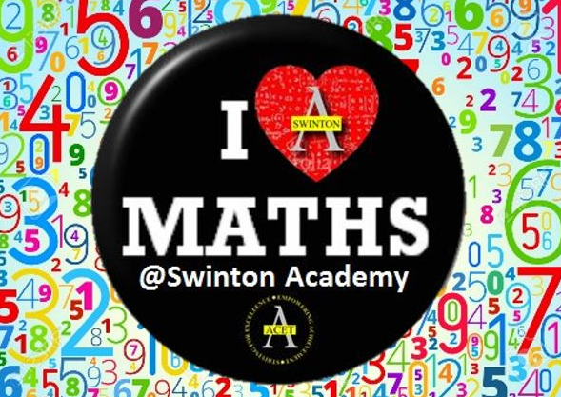

YEAR 10 C O R E
Examination
Assessments take place once in each term. The assessment is in the format you will be expected to sit at the end of Y11 and graded accordingly. This informs future learning and facilitates accurate progress mapping for each student. There is also 1 submitted piece of work for each half term which is teacher assessed. The final external exam consists of 3 OCR exam papers set in the summer of Y11.

Career and Post 16 studies
Mathematics at grade 4 or above is now an essential part of the acceptance criteria for all Post 16 education providers. In the work place most employers now insist on a grade 4 and some even a grade 5. Beyond a shadow of a doubt Mathematics is a door opener to both a world of further education and employment, an essential for budding academics and artisans alike.

Useful skills to support learning
Independent investigation and discussion. There is no better way to support your understanding of the world around you than to question and interrogate the facts. This means using maths and discussing your hypothesis and conclusion’s with others. The more mathematics you use the better your understanding of the world and the better your chances of being a success in it.

In this subject you will study
Everyday calculations with integers, decimals, fractions and percentages. Ratio and proportion along with their everyday application. Geometry and constructions in context along with 2D and 3D shapes. Standard index form, indices and their application in the sciences. Algebra, the fundamental base of all mathematics and its use in computers and logical decision making.

Subject Introduction
Mathematics the most essential of subject’s to become totally immersed in. Mathematics is a skill that is fully encompassed in everybody’s everyday life whether it’s adding up your weekly shopping bill or working out your annual tax returns. Mathematics explains the world around us and provides solutions to everyday problems for everyday people every single day.

Mathematics
“At Swinton Academy, we will make a difference”


YEAR 10 C O R E
“At Swinton Academy, we will make a difference”

Religious Studies
Career and Post 16 studies
A GCSE in Religious Studies can lead to A Levels in Religious Studies or Philosophy. It can also be useful in careers such as; education, the armed forces, health care, social work, public services, journalism, and the law.

Useful skills to support learning
- Research, analysis and presentation skills.
- Critical thinking skills and the ability to interpret information, formulate questions and solve problems.
- Ability to think philosophically and evaluate faith and culture.
- Organisational and time management skills.
- Team-working and communication skills.

Examination
- 2 written exams: 1 hour 45 minutes each
- Each worth 50% of GCSE

Subject Introduction
Religious Studies makes a significant contribution to pupils’ academic and personal development. It also plays a key role in promoting social cohesion and the virtues of respect and empathy, which are important in our diverse society. GCSE Religious Studies provides a broad understanding of the beliefs and practices of both Christianity and Islam, as well as promoting religious literacy and the contemplation of ultimate questions. Students will be able to reflect on and develop their own values, beliefs and attitudes whilst considering a range of relevant and contemporary themes and modern-world issues.

In this subject you will study
Paper 1. The Study of Religions
Christianity: beliefs, teachings, and practices
Islam: beliefs, teachings, and practices
Paper 2. Thematic Studies
Relationships and Families
Religion and Life
Peace and Conflict
Crime and Punishment



In this subject you will study
Physical Geography units include:
• The challenge of natural hazards: – Volcanoes and Earthquakes, tropical storms, extreme weather in the UK and climate change.
• Physical landscapes in the UK - Coastal landscapes and river landscapes
• The living world: - Tropical rainforests and cold environments.
Human Geography units include:
• Urban issues and challenges and the Changing Economic World
• The Challenge of resource management
Fieldwork: -
Castleton and Burbage Brook (river).

Examination
There are 3 exams. Paper 1 (Physical) – 1 hour 30 min. Paper 2 (Human) – 1 hour 30 min. Paper 3 (skills) – 1 hour 15 min.
The exam papers will assess your knowledge, understanding and ability to analyse and interpret Geographical information.

Career and Post 16 studies
Geography develops a wide range of skills. Many students go on to study Geography at A level (which is offered at Swinton) and at university.
Students who study Geography access a wide range of careers such as; Surveyor, Meteorologist – weather forecaster, School teacher, Accountancy, Law, ICT and software development, Armed services and Police.

Useful skills to support learning
- Debating
- Decision making
- Fieldwork
- Critical analysis
- Problem solving
- Investigation
- Interpreting: photos,cartoons. Diagrams and other data.

Subject Introduction
Geography is an extremely interesting and enjoyable subject to study as it is about what is happening in the world today. You will become more aware of the things that will influence your life in the future. Geography is not just about learning about interesting people and exciting places, it also involves getting out of the classroom and experiencing these for yourself; as part of this course you will complete fieldwork in Castleton and at Burbage Brook (river study) in the Peak District.
In Geography you will also develop a wide range of skills such as; maps skills, ICT / GIS (Geographical Information Systems), data presentation, investigation, maths and statistical skills.
A GCSE grade in Geography indicates to employers that you have a wide range of skills and show resilience and adaptability. Geography is a highly regarded subject with colleges, universities and employers, due to the wide range of skills it incorporates.

Geography
YEAR 10 O P T I O N S
“At Swinton Academy, we will make a difference”


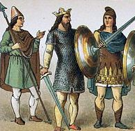
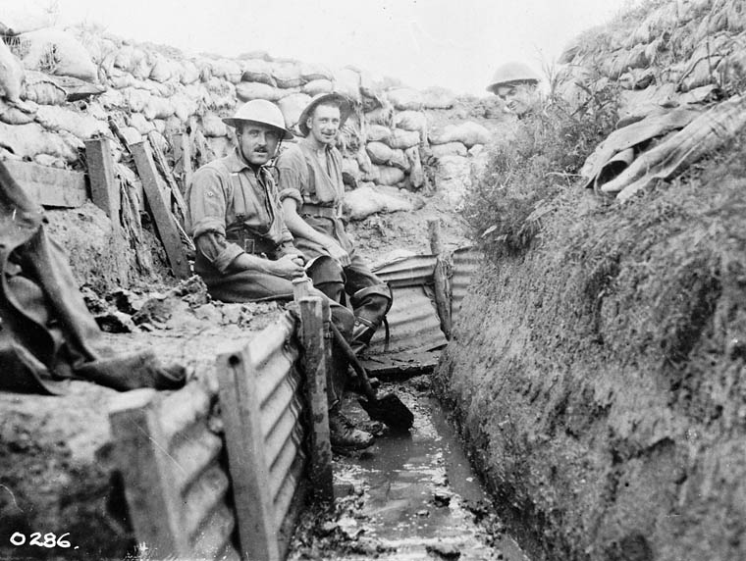
Useful skills to support learning
GCSE History allows students to develop
a range of skills including:
- Extended writing
- Source evaluation
- Interpretation analysis
- Debating
- Group work
These skills are useful in a wide range of careers.

In this subject you will study
- Medicine in Britain, c1000-present and The British sector of the Western Front, 1914-18: injuries, treatment and the trenches.
- Anglo-Saxon and Norman England, c1060-88.
- EITHER: Superpower relations and the Cold War, 1941-91.
- OR: The American West c.1835-c1895
- Weimar and Nazi Germany, 1918-39.

Subject Introduction
History is a fascinating and engaging subject that allows you to investigate how key historical events and figures have shaped our world today. You will develop a range of skills including written and verbal communication in addition to expanding your vocabulary with a wealth of new key terms and concepts. The skills you develop in History will also support your learning across GCSE subjects.
Studying History also allows you to take part in some exciting field trips. In the past we have visited the battlefields of northern France and Belgium, in addition to visiting places closer to home such as the Thackray Medical Museum in Leeds.
History is a sound academic qualification recognised by all employers and across academic institutions from colleges to universities. Some of the world’s top academics, trailblazers in business and world leaders have studied History in the past.

Examination
At the end of Year 11 you will sit 3 exam papers. Each exam paper lasts between 1 hour 15 minutes and 1 hour 50 minutes. The exam papers will test your knowledge, source skills and interpretation analysis. There is no coursework.

Career and Post 16 studies
History is a versatile and academic qualification as it teaches a range of skills which are valued both by universities and employers. Students who have studied History in the past have gone on to become solicitors, teachers, accountants, publishers, doctors, social workers, librarians and journalists amongst many other things!

History
YEAR 10 O P T I O N S
“At Swinton Academy, we will make a difference”




“At Swinton Academy, we will make a difference”
*A band will have compulsory French as part of their options
French*
Career and Post 16 studies
Post 16: A level at Swinton Academy. Post 18: Many higher education courses include a language element (e.g. business studies, engineering, IT) and also offer the opportunity to study abroad as part of your degree.
Careers: Many companies are looking for employees who have foreign language qualifications to work in positions both in the UK and abroad. Career sectors which often demand a high level of language skills include translation and interpreting, aviation industry, education, journalism, publishing, tourism, marketing and logistics.

Examination
Students will sit exams at the end of Year 11 in the four skill areas of Listening, Reading, Speaking and Writing.
Students will be entered at foundation level (with access up to grade 5) or higher (with access from grade 4 - 9) but must sit the same tier for all elements of the exam.

Useful skills to support learning
- Willingness to make oral
contributions in lessons
- Good listening skills
- Attention to detail
- Problem-solving
- Team work
- Resilience
- Appreciation of other cultures

In this subject you will study
The GCSE specification will require you to understand and use language across a range of topics, appropriate to your age, interests, and maturity levels. The topics covered include:
• identity and culture
• local, national, international and global areas of interest
• current and future study and employment
Authentic literary texts, such as extracts from poems, letters, short stories, essays, novels or plays from contemporary and historical sources, will be used in teaching. This will enhance your intercultural understanding, promote language learning and develop a range of skills.

Subject Introduction
Why learn a language?
- You will be highly employable and your language skills can add between 10-15% to your salary.
- Learning one language can help you to learn another more easily in the future.
- It boosts your memory and communication skills.
- You learn about different cultures as well as about the language itself.
- Lessons are varied and interactive.
- You’re rewarded with a real sense of achievement.
- You can use it when you travel abroad on holiday or for business.
- You won’t turn into one of those adults who say “I wish I could speak a foreign language!”

YEAR 10 O P T I O N S

Creative iMedia/Computer Science
YEAR 10 O P T I O N S

Subject Introduction
Cambridge National in Creative iMedia lets students gain knowledge in a number of key areas in the Computing field, from pre-production skills to digital animation to digital graphics, and offers a hands-on approach to learning. The Cambridge National in Creative iMedia will also provide opportunities to develop useful transferable skills such as research, planning, and review, along with developing attributes such as working with others and communicating creative concepts effectively. A vast array of software packages will be used throughout the qualification.

In this subject you will study
The modules offered include:
- Pre-Production Skills
- Creative Digital Graphics
- Interactive Multimedia Products

Useful skills to support learning
- Organisation skills
- Innovative and creative skills
- IT skills although most of these skills are developed through the course
- Attention to detail
- Ability to be flexible and adaptable
- Written skills
- Planning skills
- Strong resilience skills

Assessment.
66% of the qualification is tested by coursework that’s set and marked by the class teacher. The coursework involves students to plan and create. The remaining 33% is an external assessment where two sittings can be taken to really maximise the potential of the final grade you could achieve. This involves assessing pre-production materials such as Mind Maps and Mood boards in a 1 hour and 15 minute examination.


Career and Post 16 studies
Cambridge Nationals in Creative iMedia is excellent preparation for any student wanting to move onto further education. There are a range of courses students can move onto such as Cambridge Technical Level 3 in IT. Students have gone on to university to study Game Development, Games Design, IT with Business Studies, IT Management and so on.

“At Swinton Academy, we will make a difference”

“At Swinton Academy, we will make a difference”


YEAR 10 O P T I O N S
“At Swinton Academy, we will make a difference”

Career and Post 16 studies
GCSE Computer Science naturally leads onto A Level Computer Science. Several students who have left Swinton Academy went on to university to study Computing at degree level.
Careers in Computing are broad. Examples include: Sports Data Analyst, Software Developer, Database Administrator, Tech reviewer and journalist, Website and App designer, Hardware engineer, Data Security Engineer & Network / Cloud architect.

Examination
The qualification is divided into 2 written examinations, both 1 hour and 30 minutes and 50% each towards the final grade. The two examinations are worth 80 marks each. Questions vary from short answer questions to extended writing tasks and writing algorithms.

Useful skills to support learning
- Strong mathematical skills
- Computer programming
- Extended writing skills
- Group work and debate
- Attention to detail

Subject Introduction
GCSE Computer Science is engaging and practical course that encourages creativity and problem solving. Students learn to develop their understanding and application of the core concepts in computer science. Students also analyse problems and devise creative solutions by designing computer programs.
GCSE Computer Science develops skills that lead to further education and computing careers; however these skills are relevant to the majority of career pathways and skills that are attractive to employers.
If you’ve an interest in problem solving, programming, how computers work, this could be for you!

In this subject you will study
- Computer systems and architecture
- Networking
- Security systems
- Ethical and legal issues
- Programming and problem solving
- Computational thinking skills


Enterprise & Marketing - Business
“At Swinton Academy, we will make a difference”

YEAR 10 O P T I O N S
Examination
The qualification is divided into 3 units, two units assessed by coursework and one unit assessed by an external examination. The two coursework units are both worth 25%, totally 50% of the final grade (both out of 60 marks) while the examination unit is worth 50%, total marks being 80; therefore this is really beneficial for those who are effective at coursework.

written examinations, both 1 hour and 30 minutes and 50% each towards the final grade. The two examinations are worth 90 marks each. Both papers are split into 3 sections (Section A, B & C) each containing a short case study while questions are broken into calculations, multiple-choice, short-answer and extended-writing questions.
How will the students be examined, grade breakdowns, how many papers, coursework, GCSE or vocational, paper breakdown – long answer question

Career and Post 16 studies
Many students who have completed the course at Swinton Academy have stayed and successfully completed Business at A Level, thus leading to many individuals going on to study Business at university which is a stunning achievement. Business can lead into careers such as Game Development, becoming a director in many fields, go on to run a successful business themselves. At university, students can study courses such as Business Management, Business & IT, Business and Game Design and many more.

In this subject you will study
Enterprise and Marketing concepts
Design a business proposal
Marker and pitch a business proposal

Students will learn about:
- How to advertise, price and raise awareness of products.
- Setup up a business, selling products and setting certain pricing strategies.
Useful skills to support learning
- Innovative and creative skills
- Good attention to detail
- Ability to assess graphs/charts
- Working with numbers
- Basic mathematic skills
- Organisation skills

Subject Introduction
OCR Enterprise & Marketing allows students to select different ideas in business-related scenarios to efficiently setup and run their own business/organisation, developing many skills that can really aid all students frequently throughout their career and future aspects. Within business you will learn about factors which can affect businesses, such as Finance, Marketing and Human Resources aspects. You will look at the functional areas and job roles in businesses, as well as gaining knowledge regarding external factors. The subject explores real life businesses in different dynamic environments; for example, Sony, Nando’s, Microsoft and Coca-Cola are some of the many different businesses we assess, monitor and evaluate throughout.

Fine Art/Photography
Useful skills to support learning
A creative flair and interest for the subject is a must! To support the development and sharing of ideas, good discussion and presentation skills are helpful. Students will build on a variety of practical making skills, which are established in KS3. Confidence to try out new media and ideas will support learning and development on this course.

In this subject you will study
Students are be given the opportunity to develop and explore a variety of media. Students gradually develop from more teacher led, skills based workshops to independently produced and developed projects in their chosen media. As work progresses a variety of topics are available for students to choose from to ensure they are able to create work which is interesting and personal to them.

Examination
Students will be examined across 2 components in this course. Component 1, worth 60% of the over all grade, is based on students creating a developed portfolio of work which covers all assessment objectives in the course including artist research and response, recording ideas, experimentation with media and development/creation of ideas.
Component 2 of the course is worth 40% of the over all grade and is an externally set assignment which covers all 4 assessment objectives. The optional themes for this component are set by the exam board. Students have a prep period to create project work followed by 10 hours in order to create a final outcome for the project.

Career and Post 16 studies
Students can go on to study A level Fine Art here with us at Swinton Academy. The course will support any further study into a creative course or course which requires creative thinking, problem solving skills etc. It is great when teamed with a wide variety of other subjects including English, Drama and the Sciences.

Subject Introduction
The Fine Art course provides students with the opportunity to express themselves imaginatively and creatively using a range of media including drawing, painting, photography and much more. Students develop skills and ideas to work towards ambitious, personal creations. This course is demanding but very enjoyable and rewarding.

YEAR 10 O P T I O N S
“At Swinton Academy, we will make a difference”



“At Swinton Academy, we will make a difference”

Subject Introduction
The Photography course provides students with the opportunity to express themselves imaginatively and creatively using a range of media including photography and digital editing. Students develop skills and ideas to work towards ambitious, personal creations. This course is demanding but very enjoyable and rewarding.

In this subject you will study
Students are be given the opportunity to develop and explore a variety of media and editing. Students gradually develop from more teacher led, skills based workshops to independently produced and developed projects in their chosen theme. As work progresses a variety of topics are available for students to choose from to ensure they are able to create work which is interesting and personal to them.

Useful skills to support learning
A creative flair and interest for the subject is a must! To support the development and sharing of ideas, good discussion and presentation skills are helpful. Students will build on a variety of practical making skills, which are established in KS3. Confidence to try out new photography, editing skills and ideas will support learning and development on this course.

Career and Post 16 studies

Students can go on to study A level Fine Art and Photography here with us at Swinton Academy. The course will support any further study into a creative course or course which requires creative thinking, problem solving skills etc. It is great when teamed with a wide variety of other subjects including English, Drama and the Sciences.

YEAR 10 OPTIONS

Examination
Students will be examined across 2 components in this course. Component 1, worth 60% of the overall grade, is based on students creating a developed portfolio of work which covers all assessment objectives in the course including artist research and response, recording ideas, experimentation with digital editing and the development/creation of ideas.
Component 2 of the course is worth 40% of the overall grade and is an externally set assignment which covers all 4 assessment objectives. The optional themes for this component are set by the exam board. Students have a prep period to create project work followed by 10 hours in order to create a final outcome for the project.



Construction
YEAR 10 O P T I O N S
“At Swinton Academy, we will make a difference”

Would you love the opportunity to transform the world around you? Are you looking to learn about new technologies, materials and processes that are involved in construction projects? Do you want to develop a good foundation for a successful career in construction? If so, it’s time to – find out more about this exciting qualification today!
Unit 1: Introduction to the Built Environment (completed by all students) You will:
Be introduced to the principles of the built environment and have the opportunity to develop the skills, knowledge and understanding in identifying, explaining and evaluating different ideas and concepts of the built environment. Explore a range of professional and trade roles Explore some of the different structures and buildings of the built environment
Unit 3: Constructing the Built Environment you will:
You will study three construction trade areas of the built environment, including planning, undertaking and evaluating construction tasks.
HOW WILL I BE ASSESSED? You will have one exam for Unit 1 which will be worth 40% of your qualification. The exam will last 1 hour and 30 minutes, it will be made up of short and extended response questions. Unit 3 will be assessed via project work (no exam), which is worth 60% of your qualification. Here you will be asked to prepare and complete three trade-based tasks e.g. creating a simple lighting circuit, building a brick structure and making a wooden planter.
WHAT SKILLS WILL I DEVELOP? You will develop a range of skills which are attractive to employers, colleges and universities including:
Communication, Critical thinking, Independent learning, Research, Time management.
CAREERS WITH CONSTRUCTING THE BUILT ENVIRONMENT? The construction industry offers a wide range of exciting opportunities, from tradesperson to leading large scale construction projects, and from an architect to renovator of our historic built environment
Career and Post 16 studies
Level 3 WJEC Applied Diploma in Professional Construction Practice • Level 2 qualifications in construction, including specialist areas such as electrical, plumbing, bricklaying and carpentry • Apprenticeships in construction.

“At Swinton Academy, we will make a difference”



Examination
Assessment for this course is covered across 2 units. This comprises of a practical assessment which gives students the opportunity to research, plan and make dishes for a Hospitality and Catering scenario. Students will also sit a 90 min theory exam which covers a wide range of elements of the Hospitality and Catering industry.

In this subject you will study
The course comprises of two key units of study. Unit 1 The Hospitality and Catering Industry and Unit 2 Hospitality and Catering in Action.
Whilst working towards to completion of both units, students will be given the opportunity to research, plan, prepare and develop their own dishes. Students will develop their practical making and presentation skills and will be challenged to create restaurant quality food. Students will study functional elements of the Hospitality and Catering industry including health and safety, job roles, food nutrition and much more.

Useful skills to support learning
Although practical making skills are an asset on this course, successful students will also be able to apply their time management and problem solving skills to practical and theoretical scenarios.
The qualification has been designed to build on the skills, knowledge and understanding acquired at Key Stage 3, particularly skills related to literacy, numeracy, creativity, problem solving and enterprise. Organisation skills are a must as students will research and provide ingredients for their own practical lessons.

Career and Post 16 studies
This course could lead onto further study including
WJEC Level 3 Food, Science and Nutrition (certificate and diploma)
Level 3 NVQ Diploma in Advanced Professional Cookery
Level 3 Advanced Diploma in Food Preparation and Cookery Supervision

Subject Introduction
WJEC/eduqas Level 1/2 Vocational Award in Hospitality and Catering enables learners to gain knowledge, understanding and skills relating to the hospitality and catering sector. In addition to development of sector specific knowledge and understanding, this qualification also support learners to develop the essential employability skills that are valued by employers, further and higher education.
In this qualification, learners will also have the opportunity to develop food preparation and cooking skills as well as transferable skills of problem solving, organisation and time management,
planning and communication.

Hospitality & Catering
YEAR 10 O P T I O N S
“At Swinton Academy, we will make a difference”

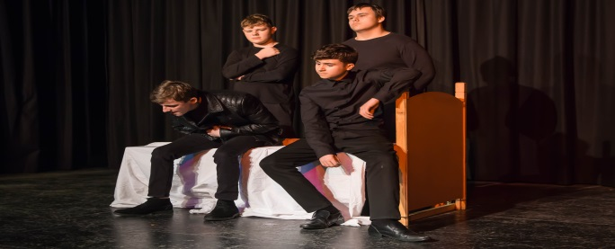

Subject Introduction
You must enjoy working with a group and giving your ideas. 40% is performance and acting so, you must have confidence to perform in front of peers and an examiner. You must have a focused and positive attitude so others want to work with you. You must be prepared to do the written element of the course, be organised to meet the deadlines so you don’t fall behind and get swamped. You should have good attendance so you don’t let others down due to the group nature of the course. It is important you are motivated and can work independently managing your own group work. You must want to see live theatre. You should enjoy giving peers feedback and commenting on the work of others. Be prepared to rehearse in your own time especially when preparing for the group performance exam. If you can do this, then we look forward to seeing you!

Examination
Component 1- An open book written exam of 1 hour & 45 minutes – 40% Component 2- A devised drama performance with coursework analysing and evaluating students’ choices of stimuli and the planning, rehearsing and performance of the piece. - 40%. This component will be marked by your teacher and moderated by an AQA examiner. Component 3- A performance of two extracts from one play -20%. This component will be marked by an external AQA examiner.

In this subject you will study
As well as essential performance skills, you will study a play and explore through performance, the decisions that playwrights, directors, actors and other theatrical professionals make. You will learn to write about this through analysis and evaluation.
You will learn to act in different theatrical styles, perform your devised and scripted pieces to audiences; both in lessons and after school. You’ll learn much about the theatre & watch & evaluate inspiring theatre productions!

Useful skills to support learning
GCSE Drama is not just about acting. The course inevitably covers all sorts of transferable skills that will be useful throughout life: communication, presentation/public speaking, group/team and leadership skills, problem solving, time management, initiative and the ability to work to a deadline and get it right first time (there are no re-runs!) You will be asked to improvise on a number of occasions so you will develop the ability to think on your feet that will help you develop the skills to take the initiative in any situation.

Career and Post 16 studies
Studying Drama is relevant to people who are interested in culture, social issues and careers. It will boost your confidence so will help you in any job that requires public speaking or entails communication skills. As well as career choices that require empathy, drama encourages critical thinking skills, which are useful in careers in management, law, and teaching, nursing as well of course - if you want a job in the entertainment industry, in front of an audience or behind the scenes!

Drama
YEAR 10 O P T I O N S
“At Swinton Academy, we will make a difference”



Career and Post 16 studies
There are a vast array of career choices available within the music and entertainment industry, from performing to production, radio and live sound, it an ever growing sector. In regards to Post 16 the GCSE progresses to KS5, where pupils may wish to continue their musical journey and begin to focus on a more specific area that caters to their particular interests and occupational intentions.

Examination - component 3
Written examination: 1 hour 15 minutes (approximately) 60% of the GCSE
This component is assessed via a listening examination. It is a paper with eight questions in total, two on each of the four areas of study:
Area of study 1: Musical Forms and Devices Area of study 2: Music for Ensemble
Area of study 3: Film Music
Area of study 4: Popular Music

“At Swinton Academy, we will make a difference”

In this subject you will study

Component 1: Performing 30% of the GCSE
A minimum of two pieces, one of which must be an ensemble performance of at least one minute duration. The other piece(s) may be either solo and/or ensemble. One of the pieces performed must link to an area of study of the learner’s choice.
Component 2: Composing 30% of the GCSE
Two compositions, one of which must be in response to a brief set by EDUQAS. Learners will choose one brief from a choice of four, each one linked to a different area of study. The briefs will be released during the first week of September in year 11. The second composition is a free composition for which learners set their own brief.
Subject Introduction
GCSE Music aims to develop performing, composing and appraising skills. It will encourage you to broaden your musical experience, develop imagination and foster creativity. Studies include music from across a diverse range of styles and genres, including the use of music technology.

GCSE Music
YEAR 10 O P T I O N S

Useful skills to support learning
Reading of information, understanding and interpreting and being able to summarise relevant information.
Applying knowledge and understanding to health and social care settings.
Working independently using the internet to complete further research to enhance learning and understanding.
Demonstrating key skills on work experience within a health and social care setting.

In this subject you will study
Three Units:
1. R031 Principles of care in health and social care – This unit will be assessed by an exam. Students will learn about key topic areas that are important when caring for and protecting people within health and social care.
2. R033 Supporting individuals through life events – This unit will be assessed by set assignment. In this unit you will learn about growth and development through life stages.
3. R035 Health promotion campaigns – This unit will be assessed by set assignment. In this unit you will research health promotion campaigns and learn about their benefit to society.

Career and Post 16 studies
After completing this qualification many students’ progress onto post 16 and study Cambridge Technical Health and Social Care level 3. Career pathways have included students moving onto Higher Education and Degrees in within the health and social care setting. Typical careers this can lead to are social worker, primary teacher, secondary teacher, nurse, paramedic, probation officer and nursery nurse.

Examination
The grading system is for vocational subjects: Distinction *, Distinction, Merit, Pass, Distinction L1 Merit L1 Pass L1

Subject Introduction
This level two Cambridge National course aims for students to develop their knowledge, understanding and practical skills that would be used within the health and social care sector.

Health & Social Care
YEAR 10 O P T I O N S
“At Swinton Academy, we will make a difference”


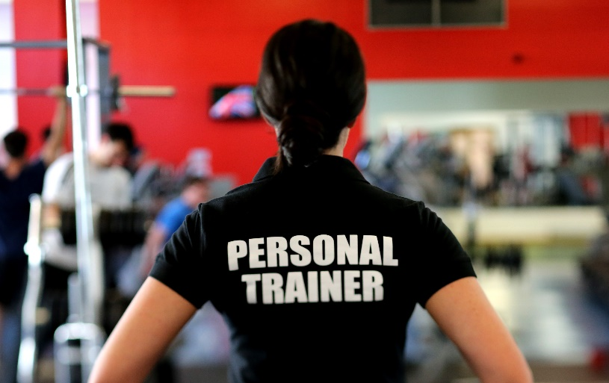
“At Swinton Academy, we will make a difference”

Subject Introduction
This course covers different aspects of Sport including Fitness, Nutrition and Sport Injuries. Lessons are both theory based and practical covering fitness testing, programmes, training methods whilst also engaging in sporting activities

OCR Cambridge
National Sport Science

In this subject you will study
• 3 units:
- R180 Reducing the risk of sports injuries and dealing with common medical conditions 48 GLH external exam
- R181 Applying the principles of training: fitness and how it affects skill performance 48 GLH internal assignment based assessment
- R183 Nutrition and sports performance 24 GLH internal assignment based assessment

Useful skills to support learning
Reading of information, understanding and interpreting and being able to summarise relevant information.
Applying knowledge and understanding to sporting scenarios Working in groups to complete fitness.
Working independently using the internet to complete further research to enhance learning and understanding.

Examination
Examination Total 3 Units:
2 units are assessed by coursework completed in lesson time. 1 unit is a formal 90 minute exam
The grading system is for vocational subjects: Distinction *, Distinction, Merit, Pass, Distinction L1 Merit L1 Pass L1

Career and Post 16 studies
Career and Post 16 studies Student can progress on to study Level 3 sport qualifications such as A Level PE, OCR Cambridge Technicals L3 or BTEC. These in turn open a pathway to Higher Education and Degrees in Sport. Typical sporting careers this can lead to are Sports Therapist, Physiotherapy, Personal trainer, Nutrition Coach, Sports Coach, PE teacher.

YEAR 10 OPTIONS



YEAR 10 C O R E
OCR Cambridge Technical in Sport and Physical Activity
OCR Cambridge Technical in Health and Social Care
Sports Coach

Useful skills to support learning
- Leadership
- Character
- Knowledge of a range of different activities
- Understanding how to lead an active lifestyle
- Understand the importance of a balanced diet
- Where to access sport locally
- Links to sports clubs

Career and Post 16 studies
Physiotherapy
Sports scientist
Journalist

In this subject you will study
- Invasion Games
  - Football
  - Netball
  - Rugby
  - Handball
  - Dodgeball
- Net and Wall
  - Badminton
  - Tennis
- Health and Fitness
  - Boxercise
  - Fitness Circuits
- Outdoor Adventurous Activities
  - Orienteering
  - Problem Solving
- Dance

Physical Education

Subject Introduction
In Year 10 Core PE we support students to make informed decisions about the Sporting Pathways they can take to lead healthy and active lifestyles beyond school. Students will be given the opportunity to select the sports that most interest them.

“At Swinton Academy, we will make a difference”

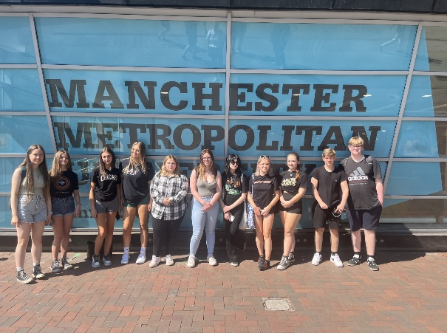
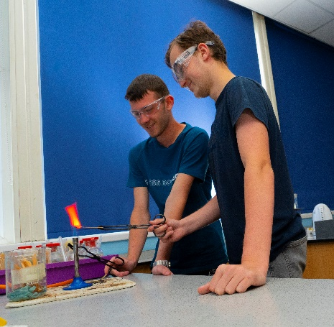
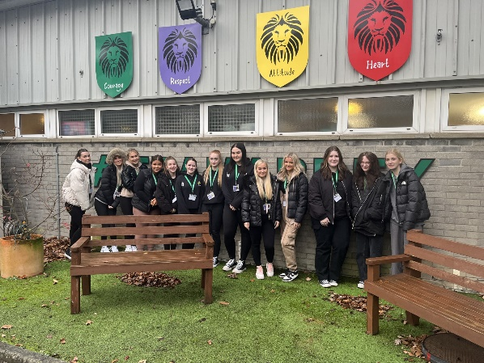

POST 16

Post 16 at Swinton Academy

Post 16 at Swinton Academy is a friendly, welcoming and supportive community of learners. Our aim, in keeping with Swinton’s mission statement, is that every student is enabled to “strive for excellence” and achieve their full potential. At Swinton Academy we provide a broad and varied curriculum which caters for a wide range of learning needs.
Swinton Academy’s Post 16 provides students with a variety of pathways, high quality teaching, extra-curricular experiences and high quality support that collectively will go a long way to support students achieve their ambitions.

Benefits to being a Post 16 student at Swinton Academy include:
- Students have their own Post 16 block which includes quiet study areas and social spaces.
- All subjects are taught by subject specialists who are experts in their field and are truly committed to helping students achieve highly.
- Our class sizes are small, typically less than ten students, so you have the confidence that you will receive the very best academic support.
- Students will have a designated tutor who will meet with you regularly as well as a post-16 team who will support students both academically and pastorally.
- Students will receive regular career advice and excellent support with applications to university, higher apprenticeships or employment. Last year 95% of our students went onto study at a university of their choice.
- All staff at Swinton Academy work hard to make sure a students life as a post 16 student is both enjoyable and rewarding. We offer a comprehensive enrichment programme helping students to develop new skills and interests and most of all having fun.
Subjects at Post 16
- Art
- Applied Science
- Biology
- Business Studies
- Chemistry
- English Language
- English Literature
- Film Studies
- Geography
- Health & Social Care
- History
- ICT
- Maths
- Modern Foreign Language
- Philosophy
- Psychology
- Physics
- Sociology
- Sport







Tel: 01709 570 586
Fax: 01709 571 563
Email: enquiries@swintonacademy.org
Web: www.swintonacademy.org

East Avenue
Swinton
Mexborough
S64 8JW

“At Swinton Academy,
we will make a difference”

